CALIFORNIA STATE UNIVERSITY NORTHRIDGE
Interior Design Program

FCS 595 BP

Interior Design and the Building Process
Professor Kyriakos Pontikis

Assignment 7:

Structure Preserving and Enhancing Transformations
Generative Design Sequences

Due date- to be announced by the Instructor

Grade- 5% of the total semester grade

Reading assignment- The Nature of Order – Book Two

Assignment Guidelines:
The aim of this assignment is to analyze the process by which good design is generated. Choose one of the projects you have done so far in this class- box, jewelry, or a book cover and document its generative design process by showing the sequential steps of unfolding. At each step of your process you have employed a transformation which preserved and enhanced the structure and wholeness of your project.
In this assignment you are asked to document and present these structure preserving and enhancing transformations of your project. Start out by writing about the vision, then going from the big centers to the smaller centers, to color, and ornamentation. For each step include the following:
- Step number and title
- Sketch or photo showing the unfolding structure of your project
- Within each step describe the sub-steps and thought process you have used to create that specific center or centers.

Once you complete your process, conclude by analyzing and critiquing your process and describing what you learned by doing this project.

Objective of the Assignment:
- Have students become familiar with the generative sequence of design
- Have students employ the principle of structure preserving and enhancing transformations
- Have students analyze important project issues such as: visions, big centers, small centers, materiality, color, ornamentation, etc.

Grading Criteria:
- Understanding of generative design sequences
- Ability to perform structure preserving and enhancing transformations for their project
- Ability to understand and analyze the unfolding structure and wholeness of their project
- Clarity and simplicity of project presentation

Example of a Generative Design Process
for a Courtyard Housing Project

STEP 1. Courtyard STEP 2. Building Volume
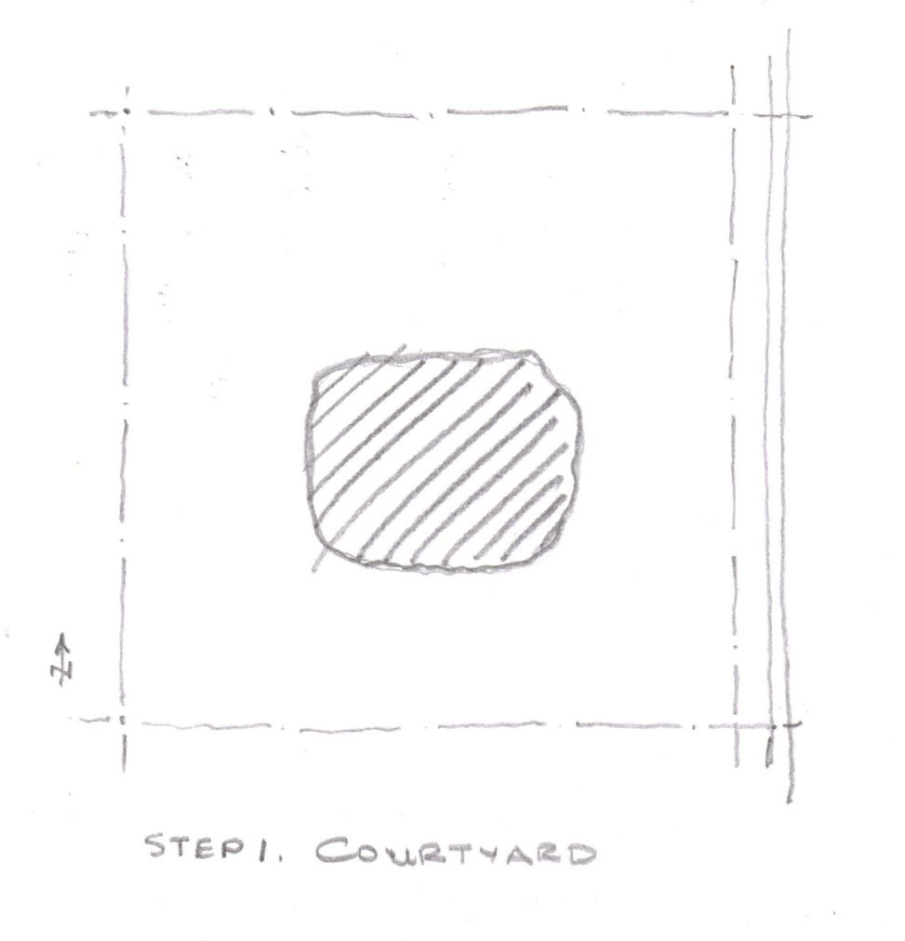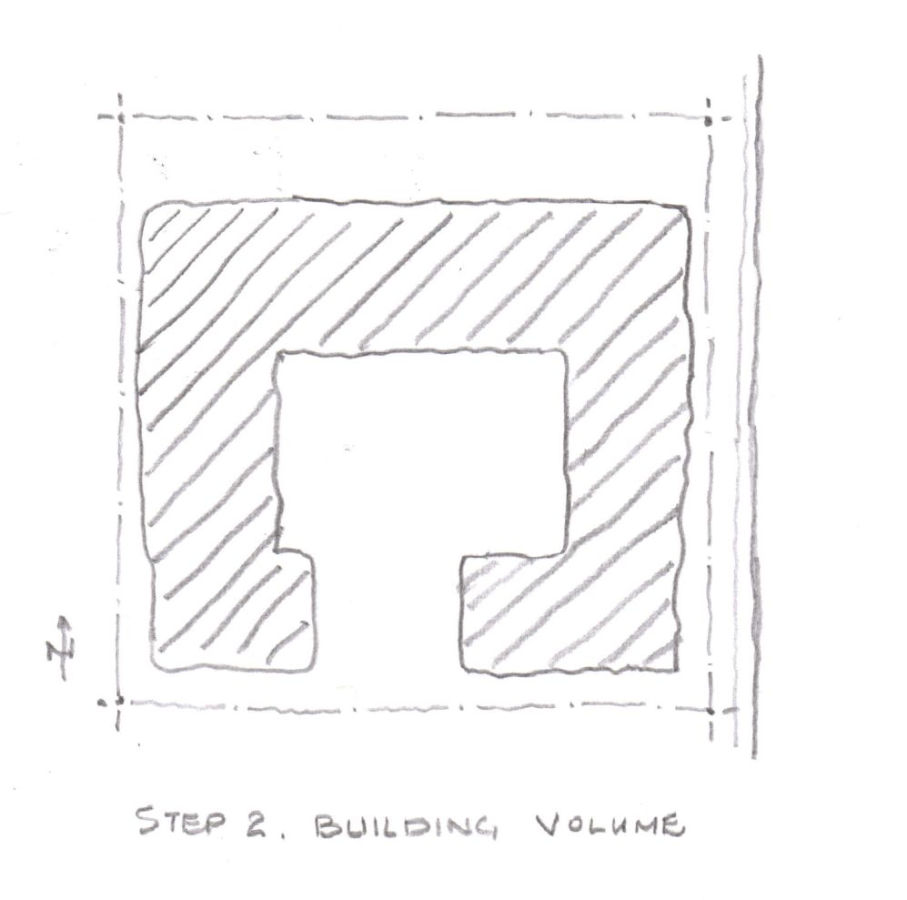
Place the courtyard Locate the volumes of the building
around the courtyard

STEP 3. Entrances STEP 4. Unit Areas
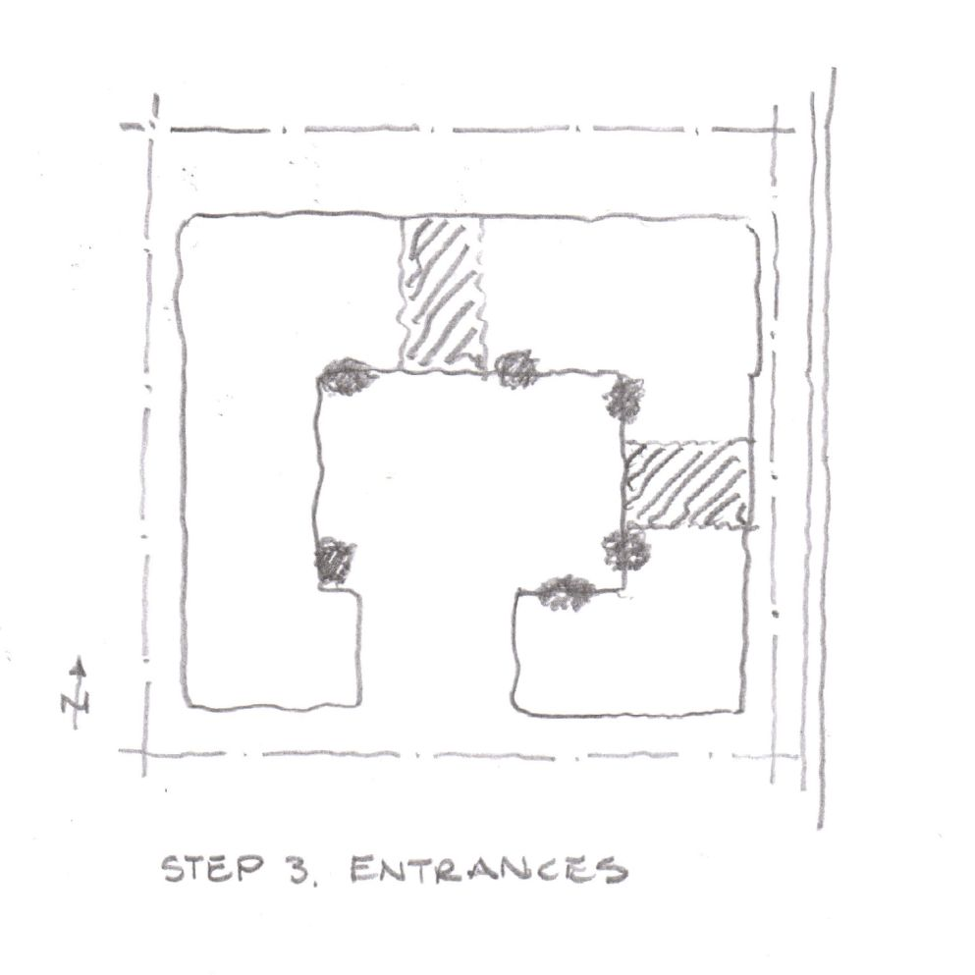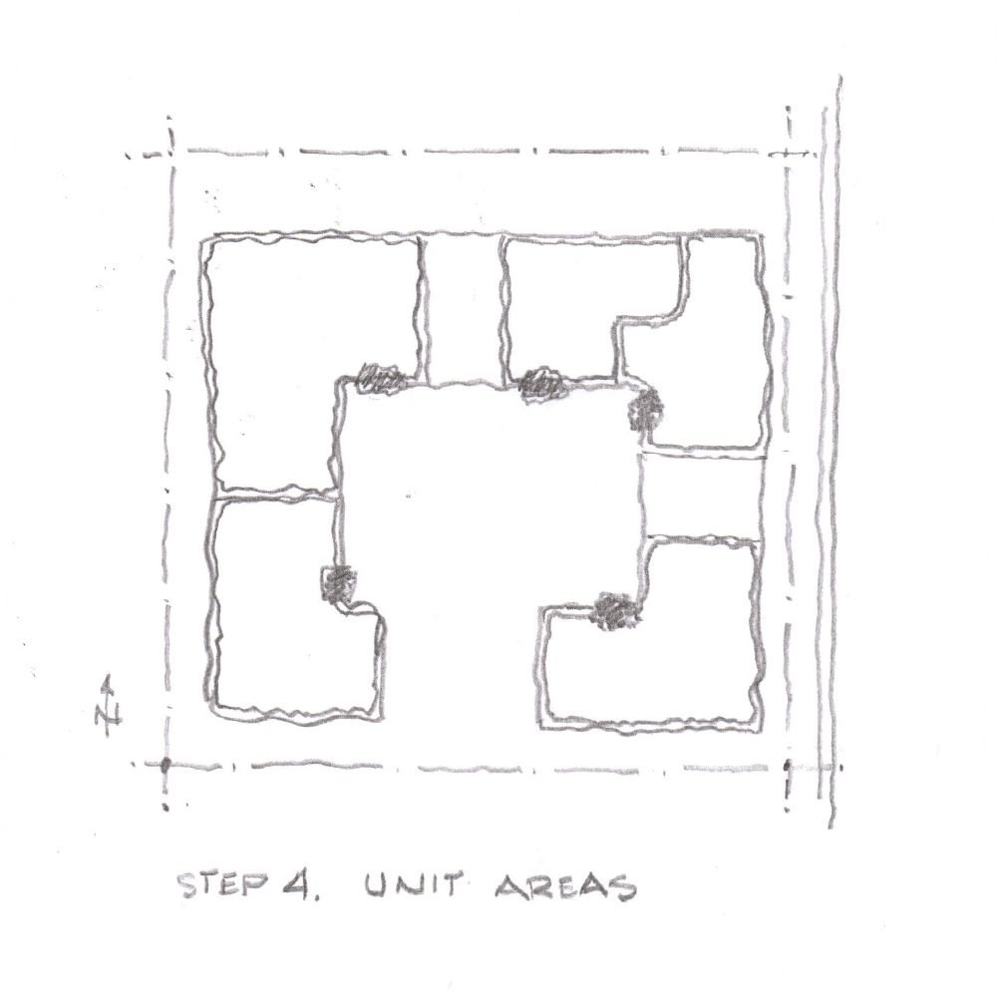
Place entrances to create Place the individual units
life in the courtyard relative to the entrances

STEP 5. Unit Layout STEP 6. Courtyard and Terraces
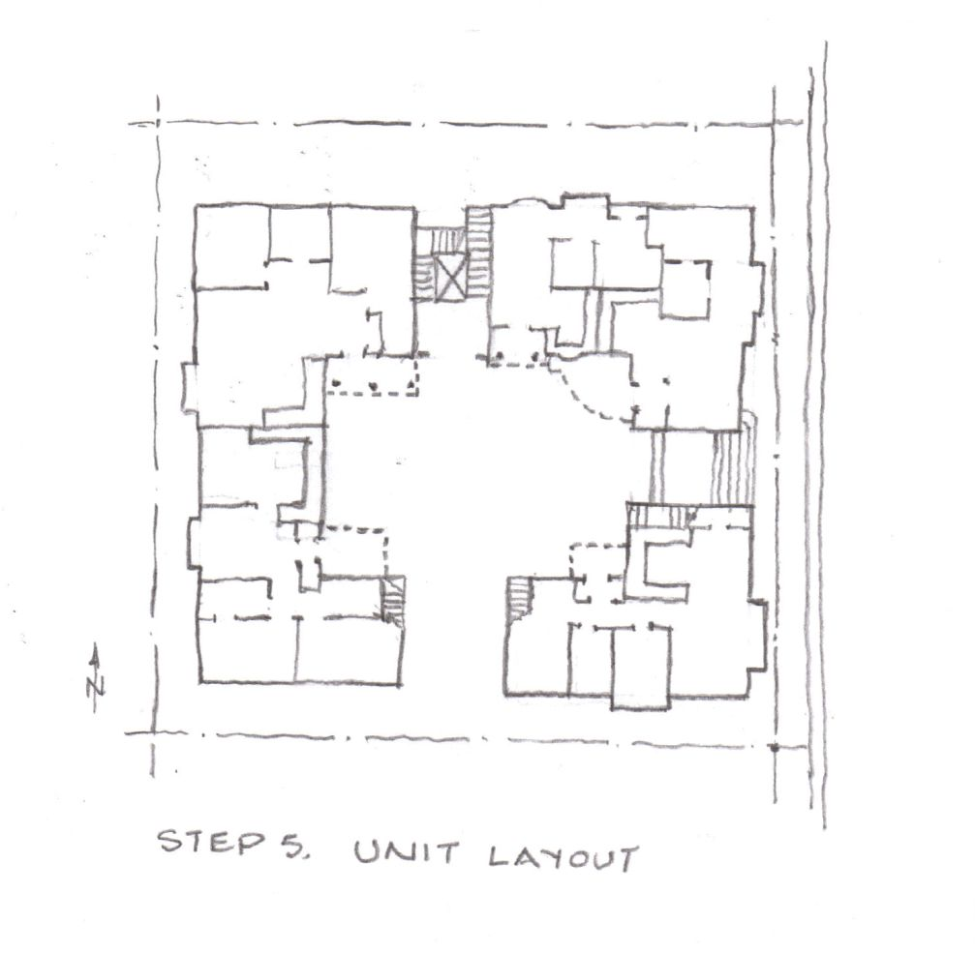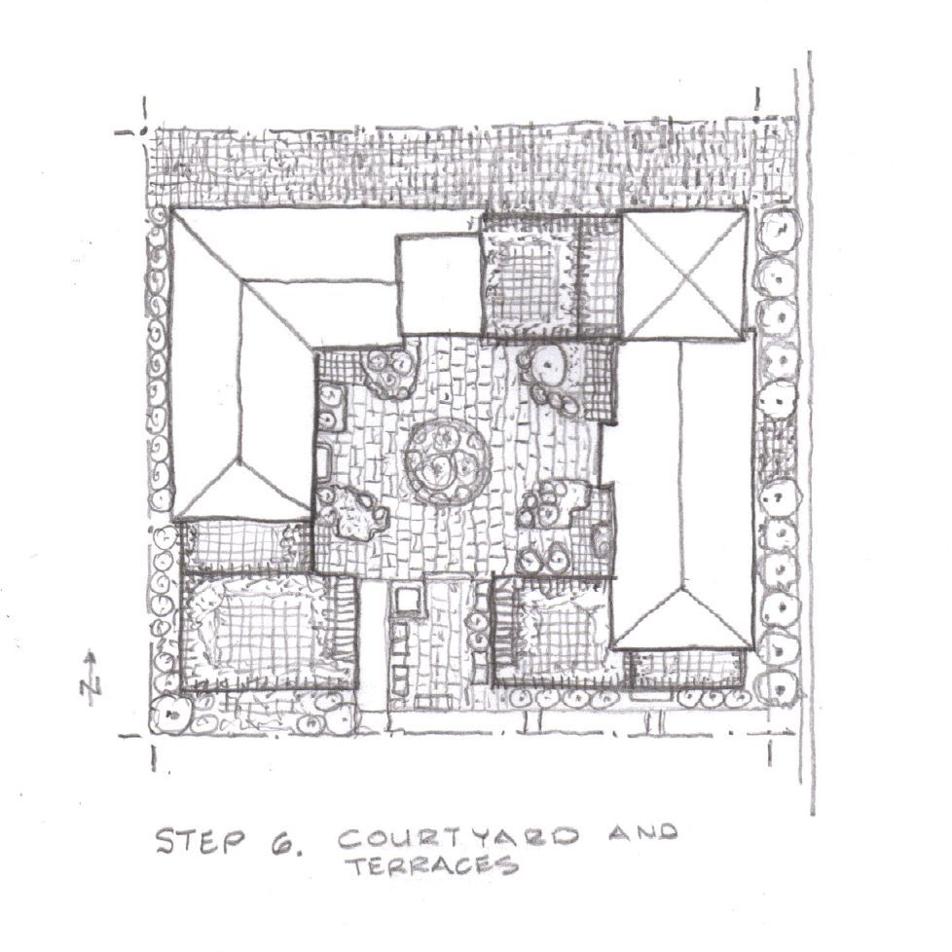
Create unit layout by starting Embellish the courtyard and
from kitchen and living room terraces

STEP 7. Adjacent Growth Step 8. Urban Transformations and Growth
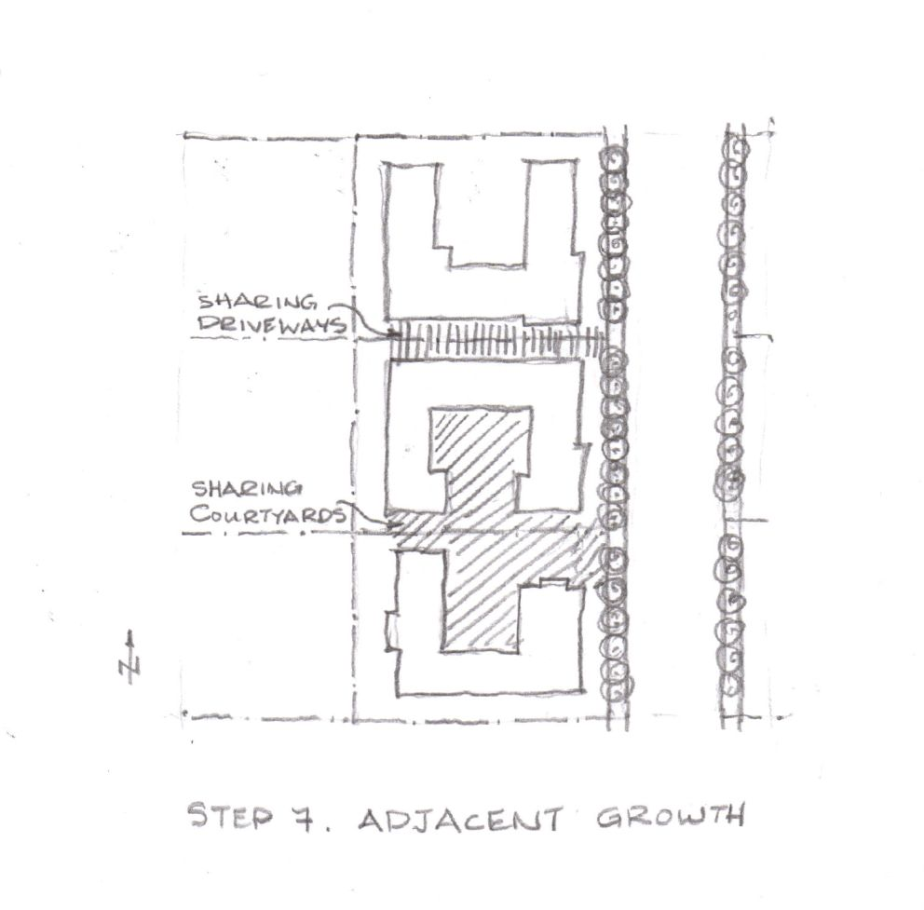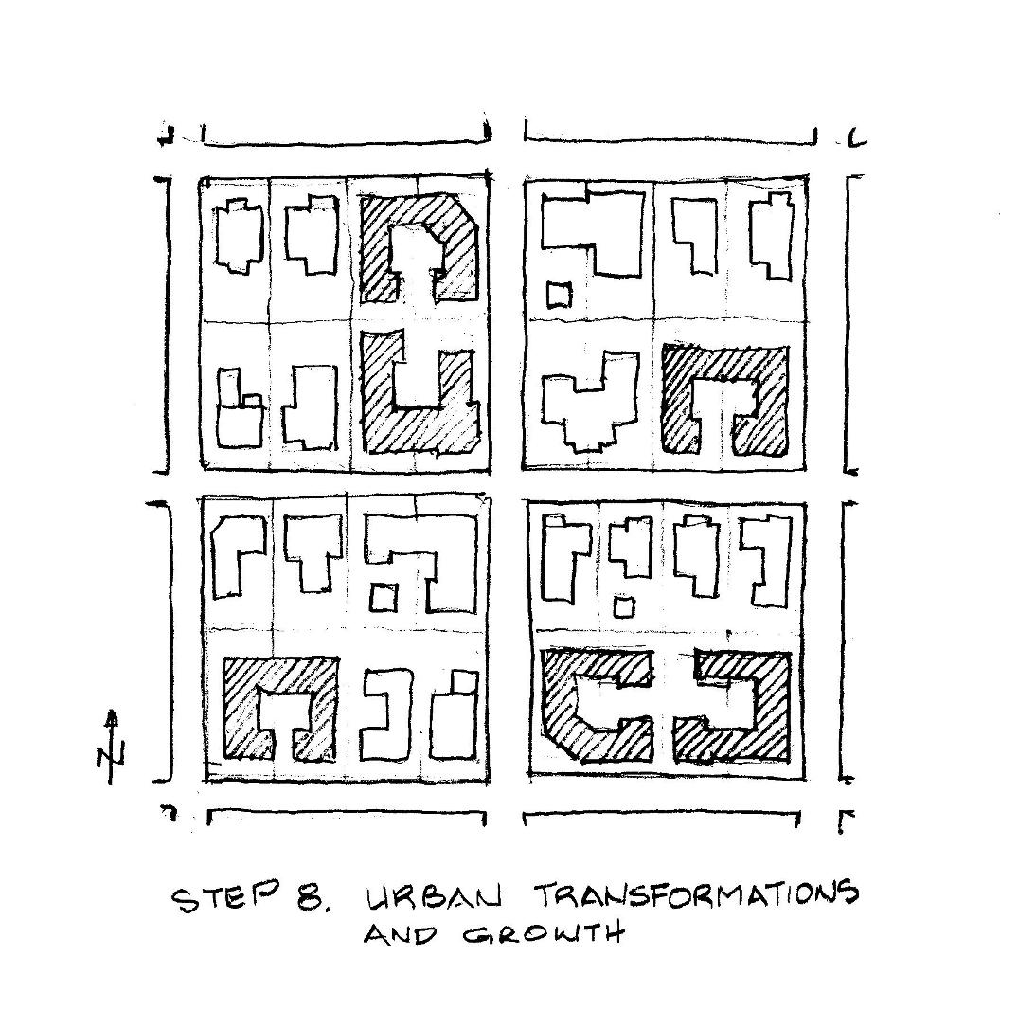
Consider adjacent growth of buildings Infill courtyard buildings creating life at the urban scale
and sharing of driveways and green spaces and unifying the neighborhood

